CIE

COPYRIGHT INFORMATION EXTRACTION FORM
TITLE: End-to-End Software Validation of an OpenCart Web Application SCHOOL: Chitkara University, Rajpura, Punjab
DETAIL OF THE STUDENT/MENTOR WHO UPLOADED THE COPYRIGHT ON GOVT PORTAL NEED TO SHARE LOGIN AND PASSWORD WITH MENTORS
Name: Suhavi jindal
Roll No/ Employee Code: 2210990867

All MEMBERS DETAILS INCLUDING SUPERVISOR

NAME | EMP CODE/ROLL | ADDRESS WITH EMAIL AND MOBILE NO.
Suhavi jindal | 2210990867 | suhavi867.be22@chitkara.edu.in ,7009128212
Umarpreet Grover | 2210990926 | Umarpreet926.be22@chitkara.edu.in ,7814080139
Dr. Monika Aggarwal | CET1001005 | monika.aggarwal@chitkara.edu.in ,9463865180

Table of Contents

PROBLEM BACKGROUND ……………….……………………………3

OBJECTIVE OF THE PROJECT…………………………………………3

PROPOSED SOLUTION / SYSTEM OVERVIEW ……………………..4

KEY FEATURES OR FUNCTIONALITY ………………………………5

TECHNOLOGY / METHOD USED ………………………..……………5

EXPECTED OUTCOME & BENEFITS ……………………..…………..6

ORIGINAL CONTRIBUTION STATEMENT………………..………….6

OUTCOME………………………………………………………………..7

ABSTRACT – End-to-End Software Validation of an OpenCart Web Application

Problem Background

The exponential growth of digital commerce has transformed traditional buying and selling processes into highly dynamic, technology-driven ecosystems. Modern e-commerce platforms, such as OpenCart-based systems, are no longer limited to basic product listings but involve complex integrations including user authentication systems, product inventory management, dynamic pricing, personalized recommendations, shopping cart mechanisms, secure payment gateways, order lifecycle management, and administrative control panels.
As these systems scale, they face challenges such as high concurrent user traffic, real-time transaction handling, data consistency, and cross-platform accessibility. Even minor defects in critical modules—such as incorrect product pricing, cart miscalculations, failed payment transactions, or delayed order confirmations—can result in financial losses, reputational damage, and reduced customer trust.
Additionally, security vulnerabilities such as weak authentication, session hijacking, and insecure payment processing can expose sensitive user data. Therefore, ensuring the reliability, performance, and security of such systems is crucial. This necessitates a structured and comprehensive software testing strategy to validate every functional and non-functional aspect of the application..

Objective of the Project

The primary objective of this project is to conduct end-to-end software validation of an OpenCart E-Commerce System by systematically testing it against its Functional Requirement Specification (FRS).

The specific objectives include:

    - Ensuring that all functional requirements are implemented correctly
    - Validating system performance under different load conditions
    - Verifying security mechanisms for safe transactions and data protection
    - Identifying and documenting defects with proper tracking
    - Ensuring the system meets business and user expectations
    - Enhancing overall system reliability and usability

Proposed Solution / System Overview

This project proposes a structured and methodical testing approach for validating an OpenCart-based e-commerce system. The system enables users to perform various activities such as browsing products, searching items, adding them to a cart, registering or logging in, placing orders, and completing payments online.

Key System Modules:

- User Registration and Login: Handles user account creation, authentication, and session management
- Product Catalog Management: Displays products with details like name, price, description, and availability
- Search and Filter Functionality: Allows users to find products efficiently using keywords and filters
- Shopping Cart Management: Enables adding, updating, and removing items
- Checkout and Payment Processing: Manages order placement and secure payment transactions
- Order Management: Tracks order status and history
- Admin Panel: Allows administrators to manage products, users, and orders

Testing Approach:

The project follows a layered testing strategy:

- Functional Testing: Validates each feature against requirements
- Smoke Testing: Ensures basic functionalities are working after builds
- Regression Testing: Confirms that new changes do not affect existing functionality

Components Evaluated:

- Authentication mechanisms
- Product and inventory management
- Cart and checkout workflows
- Payment gateway integration
- Database integrity and consistency
- Admin dashboard functionality

Each component is rigorously validated to ensure alignment with the FRS, ensuring completeness and correctness.

Key Features or Functionality Documentation Prepared:
- Test Plan: Defines scope, objectives, strategy, and resources
- Test Scenarios: High-level descriptions of functionalities to be tested
- Test Cases: Detailed step-by-step validation procedures
- Requirement Traceability Matrix (RTM): Maps requirements to test cases
- Bug Reports: Structured defect documentation with severity and priority

Functional Validation Includes:

- User registration, login, and logout processes
- Product search, filtering, and categorization
- Shopping cart operations (add, update, delete items)
- Order placement and confirmation workflows
- Payment processing and validation
- Admin operations like adding, editing, and deleting products

Defect tracking is performed systematically to ensure transparency and traceability throughout the testing lifecycle.

Technology / Method Used Testing Methodologies:
- Black Box Testing
- Functional Testing
- Regression Testing
- Smoke Testing
- Sanity Testing

Tools & Environment:

- Manual testing techniques
- Browser-based testing (Chrome, Firefox, Edge)

- Test documentation tools (Excel, Jira, or similar tools if applicable)

The system is evaluated as a web-based application, ensuring compatibility across multiple browsers and responsiveness on different screen sizes.

Expected Outcome & Benefits

The expected outcome of this project is a robust, secure, and high-performing e-commerce application that aligns with defined functional and business requirements.

Key Benefits:

- Early identification and resolution of defects
- Reduced risk of failures in production
- Improved customer satisfaction and user experience
- Enhanced system security and data protection
- Better performance under high user load
- Full compliance with Functional Requirement Specification (FRS)

This process ensures that the application is reliable, scalable, and ready for real-world deployment.

Original Contribution Statement

This project presents a structured and comprehensive testing framework specifically tailored for validating an OpenCart-based E-Commerce System. It emphasizes strict adherence to the Functional Requirement Specification (FRS) and demonstrates the practical application of software testing methodologies in a real-world scenario.

The work highlights:

- Systematic test design and execution
- Real-world defect identification and reporting
- End-to-end validation of an e-commerce platform
- Integration of both functional and non-functional testing practices

This contribution serves as a practical reference for implementing quality assurance processes in similar web-based applications.

OutcomesTestcases:

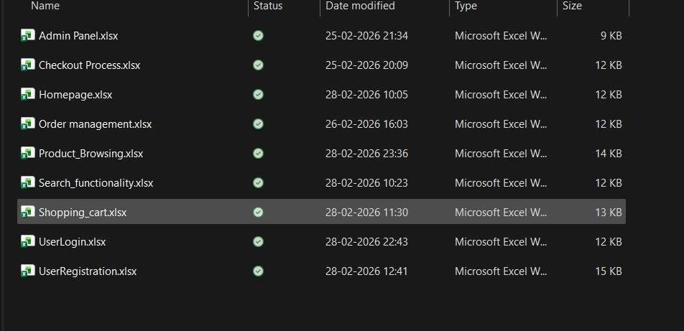

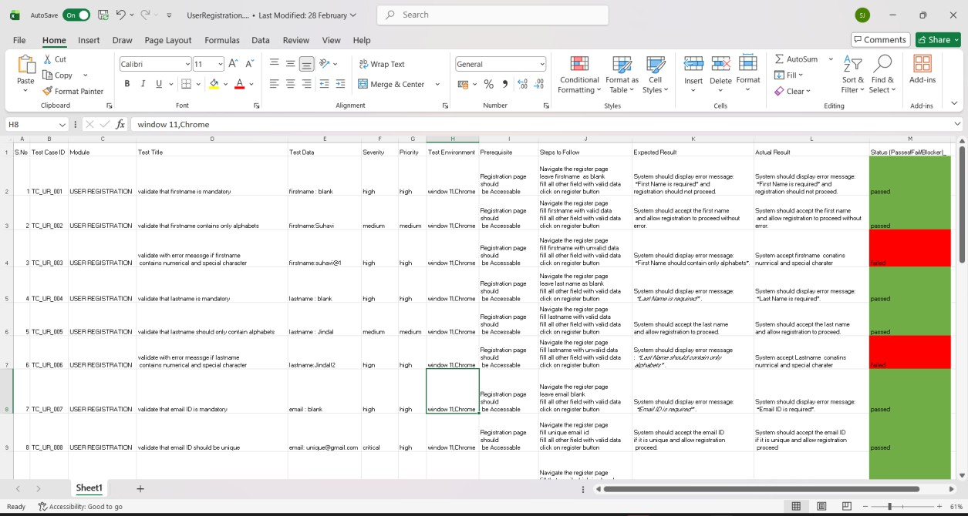



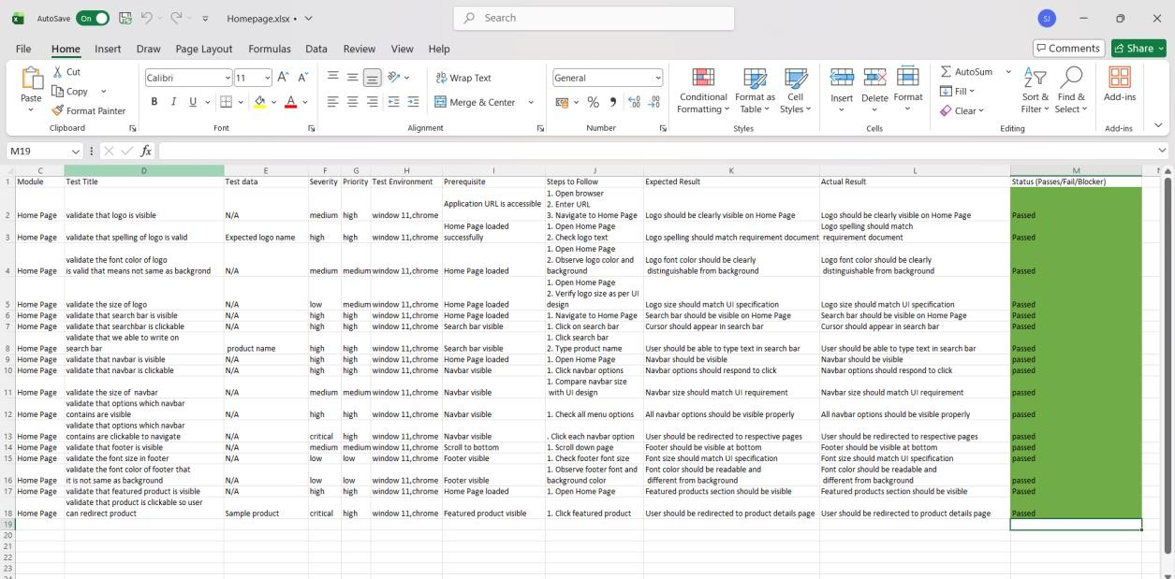

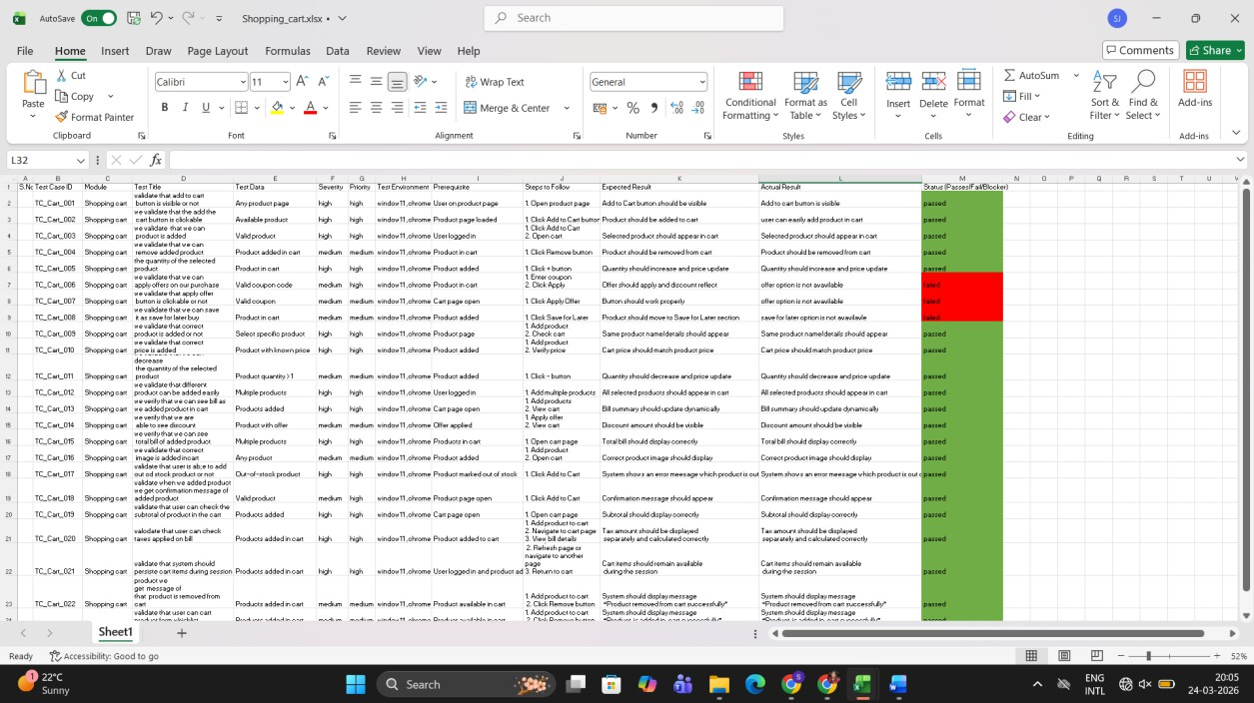

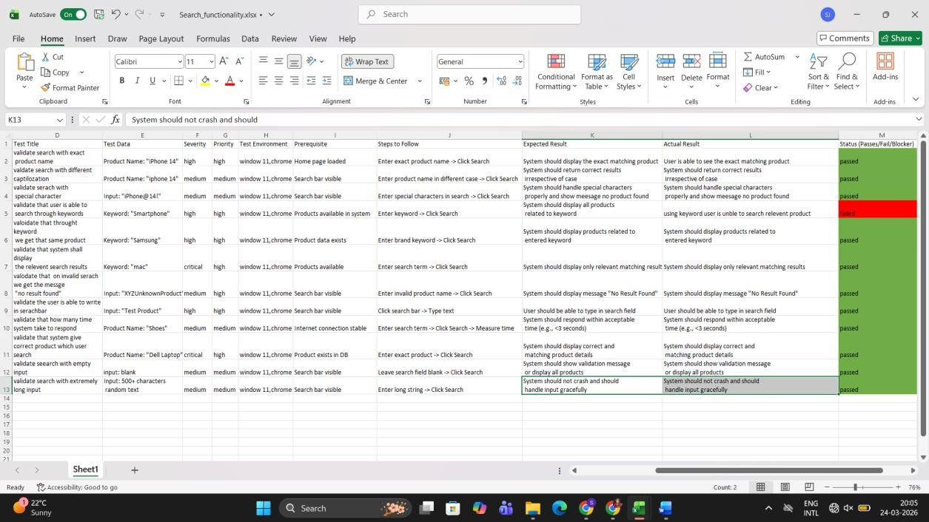

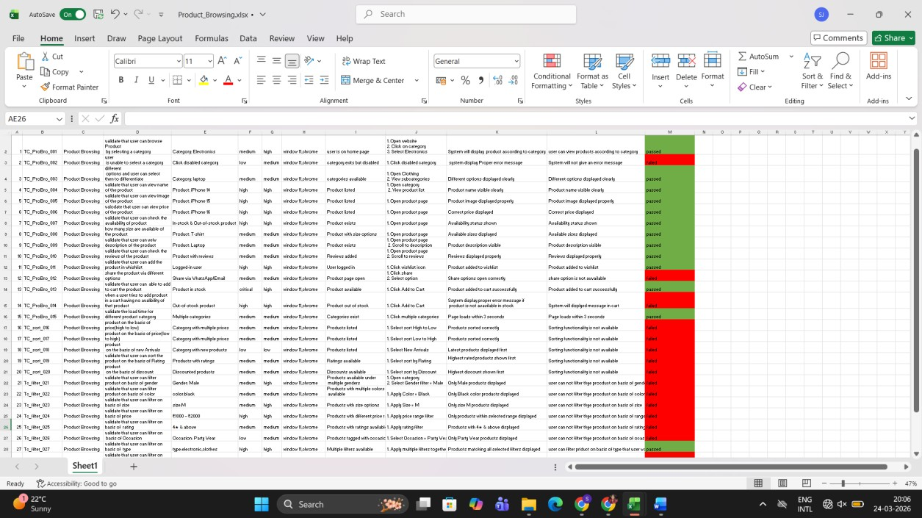

Bug Report:
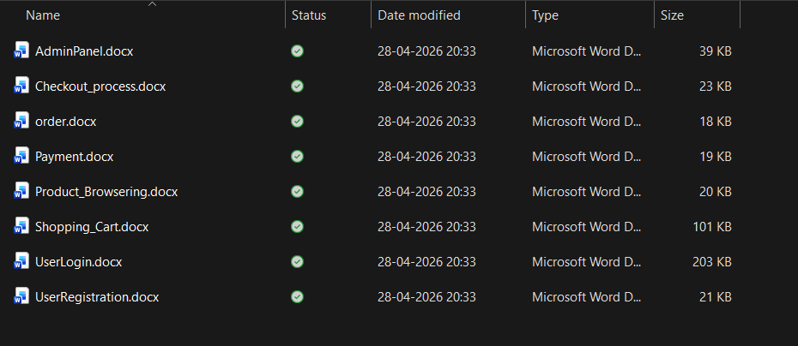

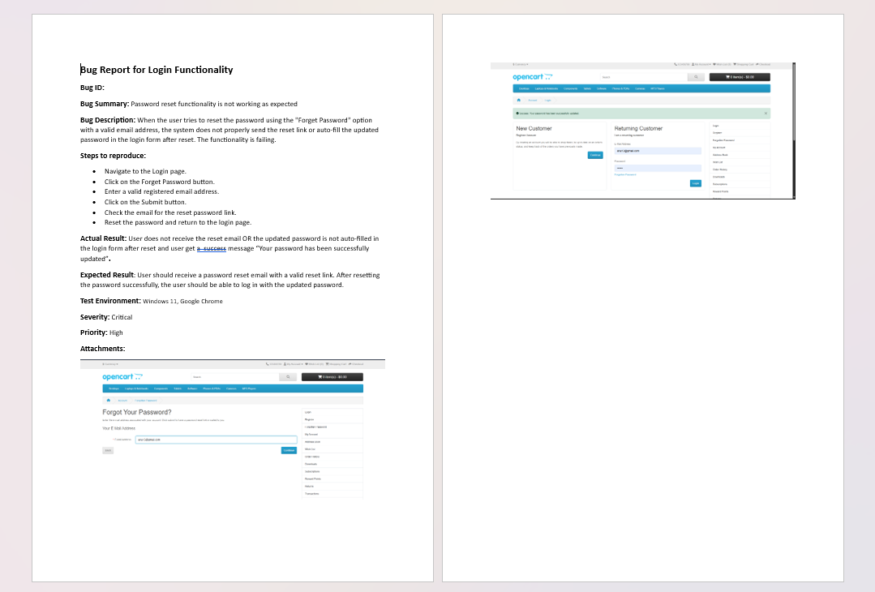
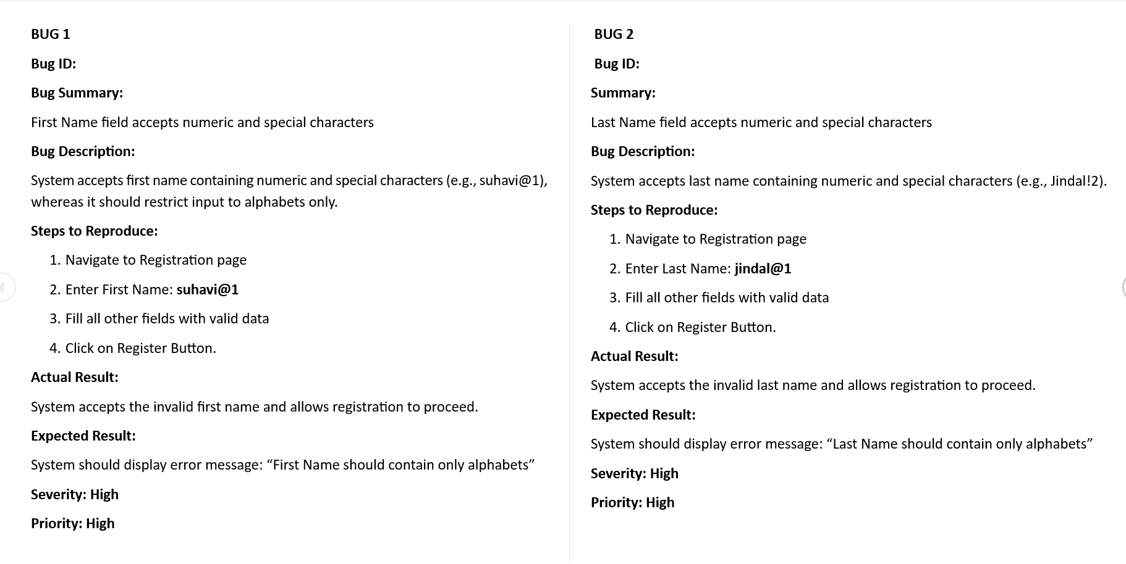

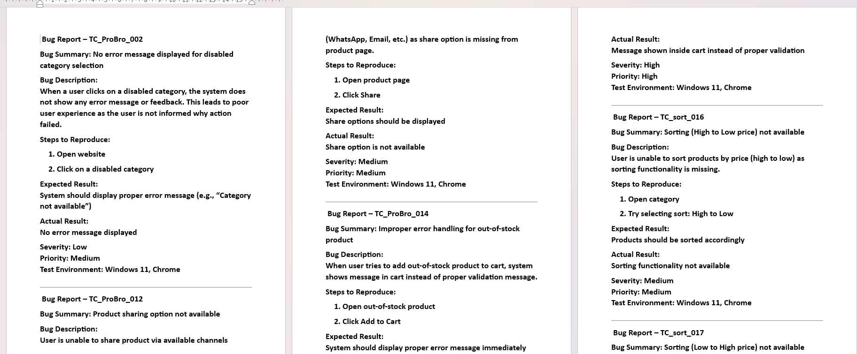

Automation Testing:

